JUNE 2018

UU Church of Weymouth
Liberal Helpings Newsletter
Sermons & Descriptions
Sunday, June 3, 2018
“Recognition Sunday”
This Sunday we will honor our outgoing Board Members and commission
our new Executive Board Members for the 2018-19 year.
Beau Rivers, Minister
Our second free monthly meal, CommUnity Luncheon, is offered after the service.

Sunday, June 10, 2018
“RE Sunday”
Historically, the second Sunday in June is a time when Unitarian Universalist
congregations focus on the achievements of their Religious Education Program.
This is an opportunity to also thank our volunteer teachers and members of
the Religious Education Committee for their hard work and dedication
to the faith formation of our children.
Beau Rivers, Minister

Sunday, June 17, 2018
“Flower Communion Sunday”
The Flower Communion is a ritual unique to Unitarian Universalism that
celebrates the end of the church year. Everyone is encouraged
to bring a flower
to church for this special occasion.
Beau Rivers, Minister


Minister’s Message
As our time together comes to an end, I want to say what an honor it has been to serve
as your minister these past two years. Thank you for welcoming me into the life of this
beloved community. I have learned so much from my ministry with each of you. While it
saddens me to say Good-bye, I am confident we will both continue to grow in ways we
cannot yet imagine.

Change is never easy and comes with varying degrees of doubt, anxiety, grief, and
excitement. Our resilience, however, depends on how much faith we have in ourselves
and each other. We need the love, support, and knowledge of others in our lives to lift
our spirits, celebrate our successes, heal our wounds, mourn our losses, appreciate our
differences, and adapt to the changes in our lives. It is this network of mutuality that
gives us hope as we face the unknown.

I want to take this time to express my gratitude to the Board for the way in which they
have navigated the many challenges of this past year. Their perseverance and
dedication to the current and future well-being of UU Weymouth deserves our utmost
love and support. May you continue to promote yourselves in new ways in the community that shares the good news of Unitarian Universalism. Embrace technology, develop new skills, and
experiment with new ideas. New opportunities will present themselves and new people
will join you in the search for truth and meaning on this marvelous journey called life.
I hope you have a wonderful summer and many new adventures in the years ahead!

May the warmth of the summer breeze,
The smell of the ocean air,
The beauty of the setting sun,
The magnificence of a starry night,
Renew your spirit, and restore your
Confidence in the mystery of creation and in the hope for a bright tomorrow.

Many Blessings,
Beau

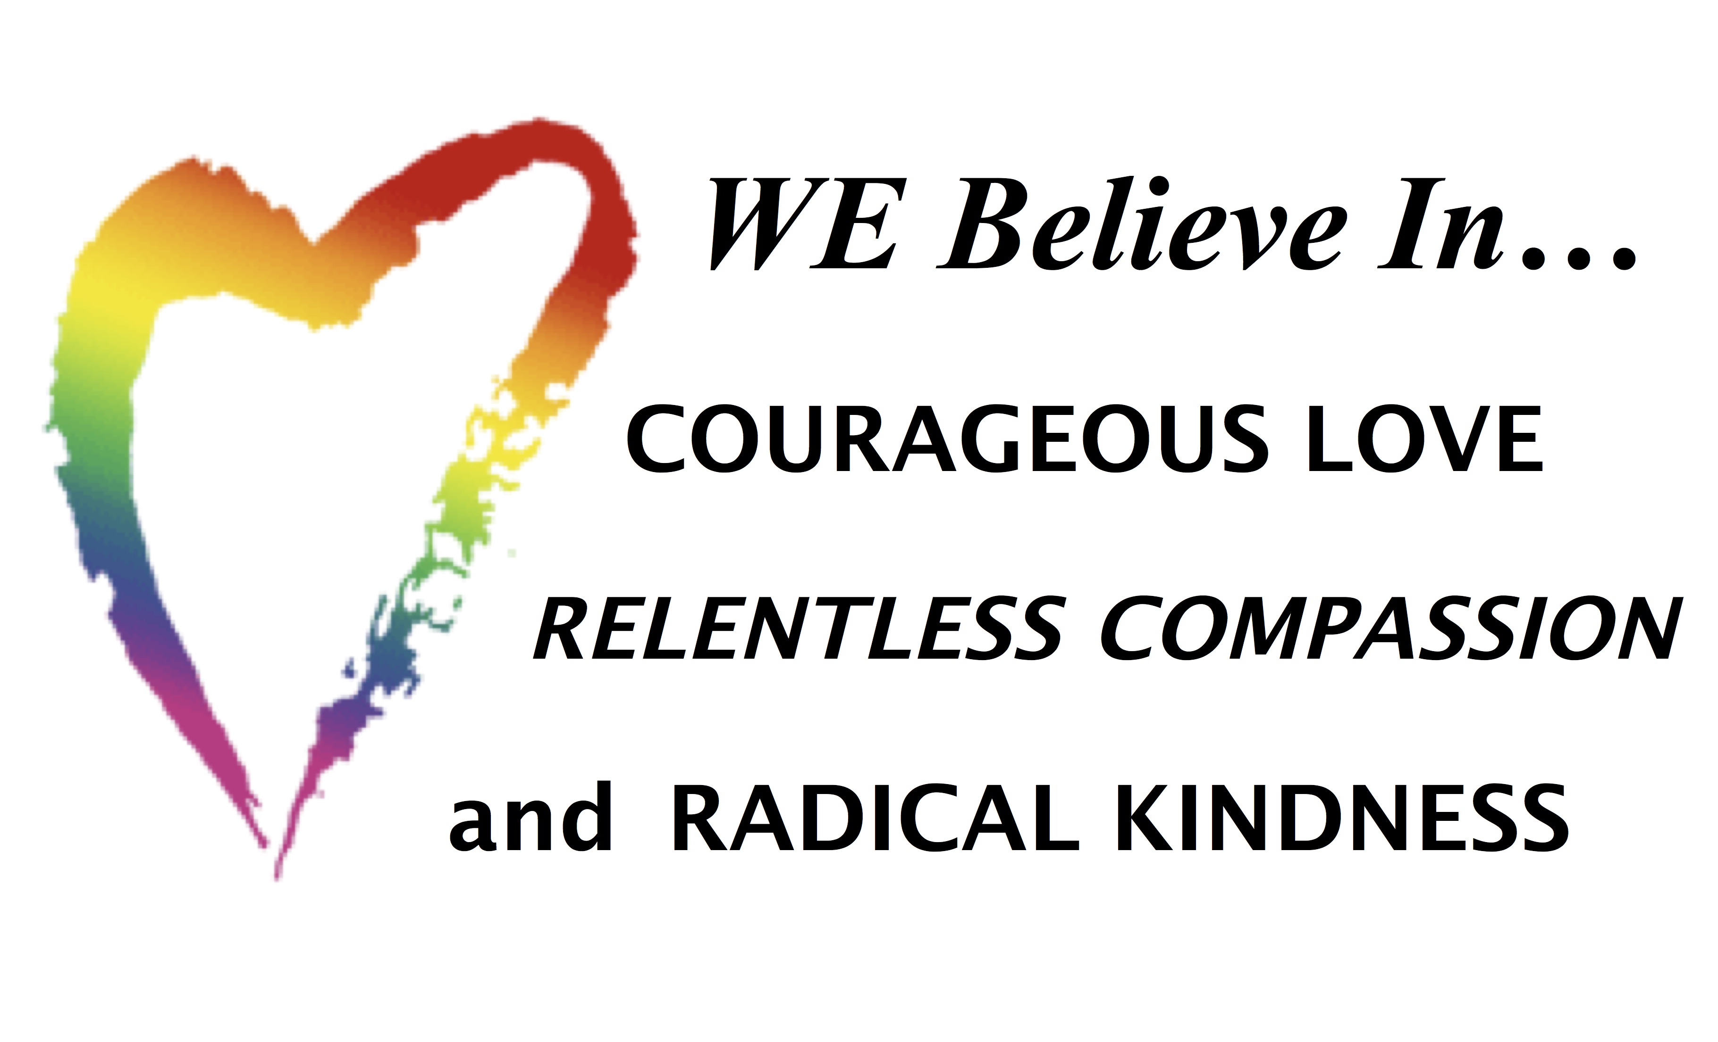
Our Mission
This is a home where people foster religious liberty, spiritual and intellectual growth, diversity, action in accord with social conscience, and the search for what is true and right.
Purpose of This Church
The purpose of this church is to provide spiritual, intellectual, emotional, religious and social stimulation, support, and freedom. It is an organization of all persons dedicated to the principles of a free faith. We are a fellowship of learners, and each is accepted as he or she is. The binding requirements on all of us is the spirit of the open mind and the experience of growth. Those who enter into membership here are in accord with this purpose and with the Constitutional guarantee of religious freedom to its ministers and members. We pledge ourselves, as far as we are able, to contribute to the support of this church, to attend its services, and to share in its work. This congregation welcomes all persons without regard to age, gender, sexual orientation, physical ability or race. We strive to be actively inclusive of all persons.
~~~~~~~~~~~~~~~~~~~~~~~~~~~~~~~~~~~~~~~~~~~~~~~~~~~~~~~~~



Executive Board
Jeanne Moretto (through 2019)
Lauren Ells (through 2020)
Amanda Loring (through 2020), Brandon DeYoung (through 2019),
Sue Donovan (through 2020)

Clerk – Theresa Szymczuk (through 2019), Moderator – John Donovan (through 2019)
Treasurer – Brandon DeYoung (through 2019), Assistant Treasurer – Lauren Ells (through 2019)
Delegate to UUANER – Amanda Loring (through 2019)

Among Ourselves
Great news that Sue Burkard made out well with her recent heart procedure.
Theme of Giving in June will be monetary donations for our CommUnity Open
Luncheons on Sundays, June 3rd, July 1st, and August 5th from 12-2:00
in Fellowship Hall.
Coffee Hour Sign-Up Sheet is located in Fellowship Hall each Sunday.
Greeters are needed on Sunday mornings to welcome members, friends, and
guests, and to hand out orders of service, light the altar candles, and update
hymn selections. Volunteers need to arrive by 10:10. Please speak with
Richard Bacon if you can help.

Religious Education
June 3rd – Session 9: GENEROSITY
As Unitarian Universalists, we engage in generosity and other acts of goodness not
for a promise in a future life, but in order to create a better world for ourselves and
others in the here and now. This session assumes that generosity stems from an
attitude of gratitude and a feeling of abundance, both of which grow with giving. In
the United States, children are immersed in a culture that promotes accumulation
and materialism. This session counteracts that lifestyle with an opportunity to
experience the joy of giving. Generosity is added to the Moral Compass.
June 10th – RE Sunday
Children and teachers will participate in today’s service. There will be no RE classes.
June 17th – Session 10: BALANCE
This session focuses on interconnections. It communicates to children both facts
and meaning of the interdependent web of life, and aims to instill the need to act
responsibly. Participants will hear a true story about human attempts to control
nature with unexpected (and undesirable) results. With an emphasis on living in
balance and harmony with nature and being mindful — even shrinking — the
footprint we humans leave on planet Earth. Balance is added to the Moral
Compass poster.
Concerning Weymouth UUs
CommUnity Luncheon takes place on Sundays June 3rd, July 1st, and August 5th.
Annual Book & Yard Sale will be on Saturday, June 9th from 9-2. Please speak with Lauren Ells to donate goods and help set up, sell, and clean up.
Annual Meeting occurred on Sunday, May 20th and was well attended and productive.
Executive Board Directors’ list is located in the Minister’s Study and in this and every issue of the newsletter. All members are welcome to attend Board meetings and to view Board meeting notes whenever they wish. Copies are kept in a binder in the Minister’s Study. Agenda deadline is on Fridays prior to the meeting. The next meeting date has yet to be set.
RE Committee meeting is on Monday, June 11th at 7:00 pm.
Worship Committee meeting will be held on Monday, June 4th at 7:00 p.m., and every first Monday of each month.
Newsletter deadline is on the fourth Sunday of the month. Summer news items are due no later than Sunday, August 26th.
Men’s Breakfast is at The Venetian on Broad Street in East Weymouth on Sunday, June 10th at 8:45 a.m. Breakfasts are on the second Sunday in the month unless noted otherwise.
Ladies Night will resume in the fall.
AA Group meets on Friday and Sunday evenings.
AlAnon meets on Monday and Wednesday mornings.

Local, District & UU Happenings

Horizons for Homeless Children needs volunteers in Weymouth & Norwell to play with homeless children a few hours per week. Please see the flier in Fellowship Hall for more information.

UU Literature is located on the information table in Fellowship Hall. You will find notices about Rowe Camp events, UU Urban Ministry, New England Region UUA, Old Ship Coffeehouse, NODA, Drug Resistance Programs, sponsorship of our little girl, and more.

Please check out our extensive library in the rear of Fellowship Hall. For some very small change, you can expand your knowledge and brighten your world.

Visit our UU Weymouth website at www.uuweymouth.org.UUA mailing address is now 24 Farnsworth Street. Boston, MA 02210-1409.


Saturday, June 9th 9-2
and
CommUnity Lunch
Sunday 12-2 June 3, 2018
Welcome Summer

